Practical no. 17
Name :- Danish Altaf Solkar Enrolment no. :-24111590805
Class :- CO3K – B Subject :- DMS
Aim:- Create and manage Views for faster access on relations.

QUERY :- CREATE TABLE Employee(ID NUMBER(3), NAME VARCHAR(30), PLACE VARCHAR(20), SALARY NUMBER(6));
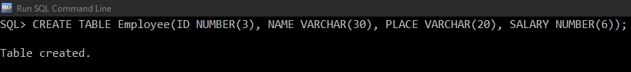

QUERY :- SELECT * FROM Employee;
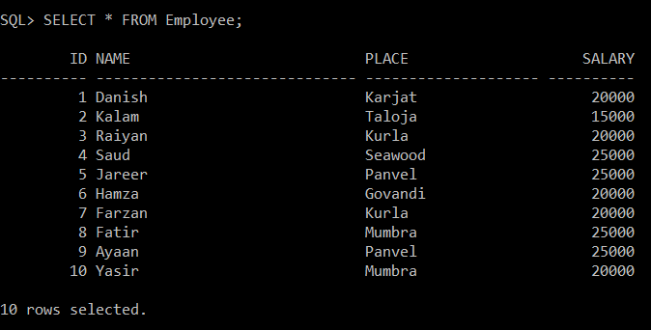

QUERY :- CREATE INDEX empempname on Employee('Name');
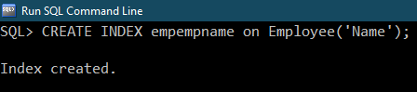

QUERY :- SELECT Index_name from user_indexes;
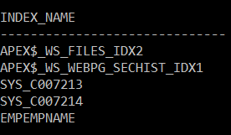

QUERY :- CREATE VIEW empv as SELECT NAME, PLACE from employee;
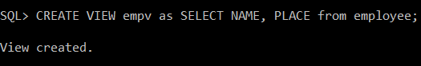

QUERY :- SELECT * FROM empv;
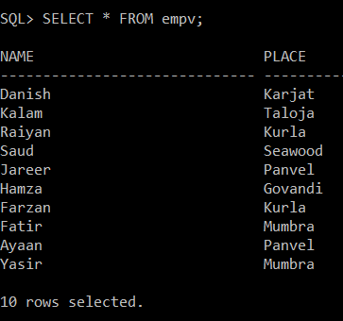

QUERY :- INSERT INTO empv VALUES ('Hussain','Kurla');
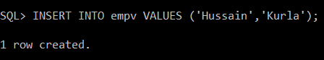

QUERY :- SELECT * FROM empv;
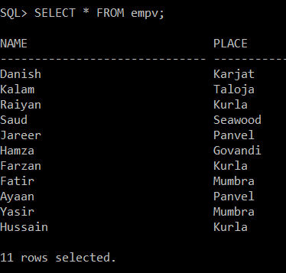

QUERY :- SELECT * FROM employee;
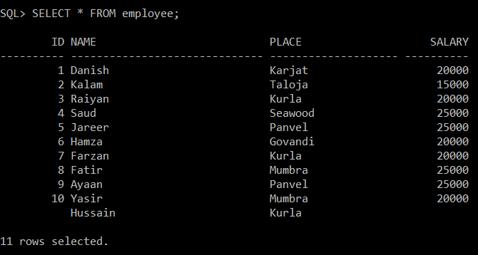

QUERY :- UPDATE empv SET place = 'New Panvel' WHERE Name = 'Ayaan';
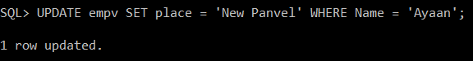

QUERY :- SELECT * FROM empv;
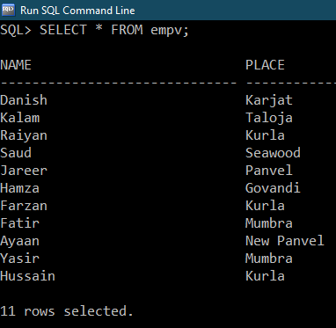

QUERY :- SELECT * FROM Employee;
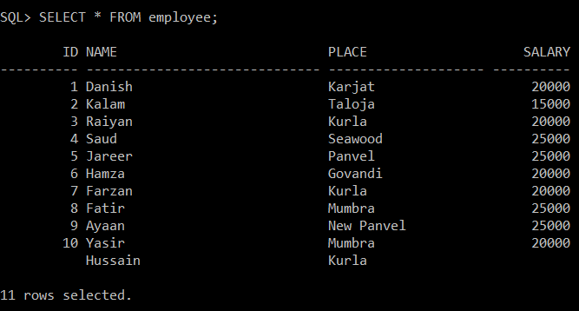

QUERY :- CREATE SEQUENCE sq;
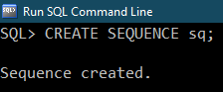

QUERY :- SELECT sq.nextval FROM dual;
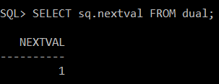

QUERY :- SELECT sq.currval FROM dual;
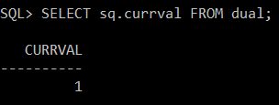

QUERY :- SELECT sq.nextval FROM dual;
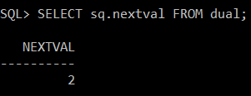

QUERY :- SELECT sq.nextval FROM dual;
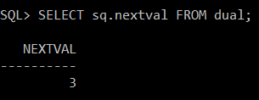

QUERY :- SELECT sq.currval FROM dual;
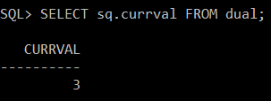

QUERY :- CREATE table stud(Enroll INT, Name VARCHAR(20));
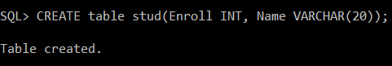

QUERY :- CREATE SEQUENCE sq1;
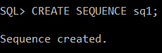

QUERY :- INSERT INTO stud VALUES(sq.nextval,'Danish');
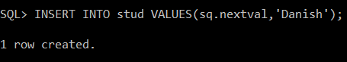

QUERY :- SELECT * FROM STUD;
